Flexibility of electricity production project documentation

The flexibility of electricity production project consists of two parts: the security of supply calculation (added in the 2nd half of 2011) and the backup for volatile electricity production calculation (added in the 1st quarter of 2012). The project was done in cooperation with GasTerra. This document contains details about the 2nd calculation: backup for volatile electricity production. For information about the security of supply calculation see the ETM wiki: http://wiki.quintel.com/index.php/Loss_of_load

Introduction
The gas flexibility project was conducted to communicate the limitations of volatile electricity production in contributing to security of supply and the necessity for backup.
The security of supply calculation shows the loss of load probability of a scenario by taking into account the reliability of electricity production and therefore shows whether a scenario has sufficient reliable production capacity (for an explanation of some of the terms used here, see definitions below).
The backup capacity calculation offers a comparison between fossil fuel technologies in terms of their ability to serve as backup for volatile electricity production. The comparison is made by considering only the costs and CO₂ emissions exclusive to providing backup for volatile electricity production.

Definitions
- Loss of load probability – The chance that a power generation park is unable to meet the expected demand. In most power systems this value should be very close to 0%. A non-zero value however does not imply that a blackout will occur, since often it is the case that electricity can be imported if it cannot be locally produced.
- Unreliable electricity production capacity – Capacity that cannot always be counted on due to unpredictability and (unexpected) maintenance requirements. Unreliable capacity includes most volatile electricity production (solar PV and wind) as well as the average expected unavailability of fossil fuel power plants.
- Reliable electricity production capacity – As opposed to unreliable capacity, reliable capacity is the fraction of the total production capacity that can be deemed reliable. This includes the majority of the fossil fuel production capacity (with exclusion for the unavailability) and some volatile electricity production capacity (depending on the capacity credit).
- Capacity credit – This is a term used to express a technologies ‘contribution to capacity’. The capacity credit is expressed as a percentage and is the fraction of the capacity that can be relied on. For example: Solar PV panels have no capacity credit since there is not always sun. Fossil fuel power plants on the other hand have a very high capacity credit because these are controlled and are available to produce electricity when needed. Finally, for the Netherlands, wind turbines have a capacity credit of approximately 14-20%. This implies that approximately one-fifth of wind turbine capacity is reliable, which depends on the assumption that the wind turbines are sufficiently dispersed over a large geographic area.
- Additional capacity – Backup capacity for long periods of no wind/sun.
- Reserve capacity – Capacity dedicated to dealing with fluctuations due to forecasting errors on short time scales (<1 hour).

Visualization in the ETM

The flexibility of electricity production has a prominent place in the ETM. First off the security of supply calculation has a dashboard item, which can be accessed via the flexible dashboard, this item is called the “loss of load probability” (see definitions). Also the security of supply calculation and the backup of electricity options have their own place in the ETM under the tab “Supply”.

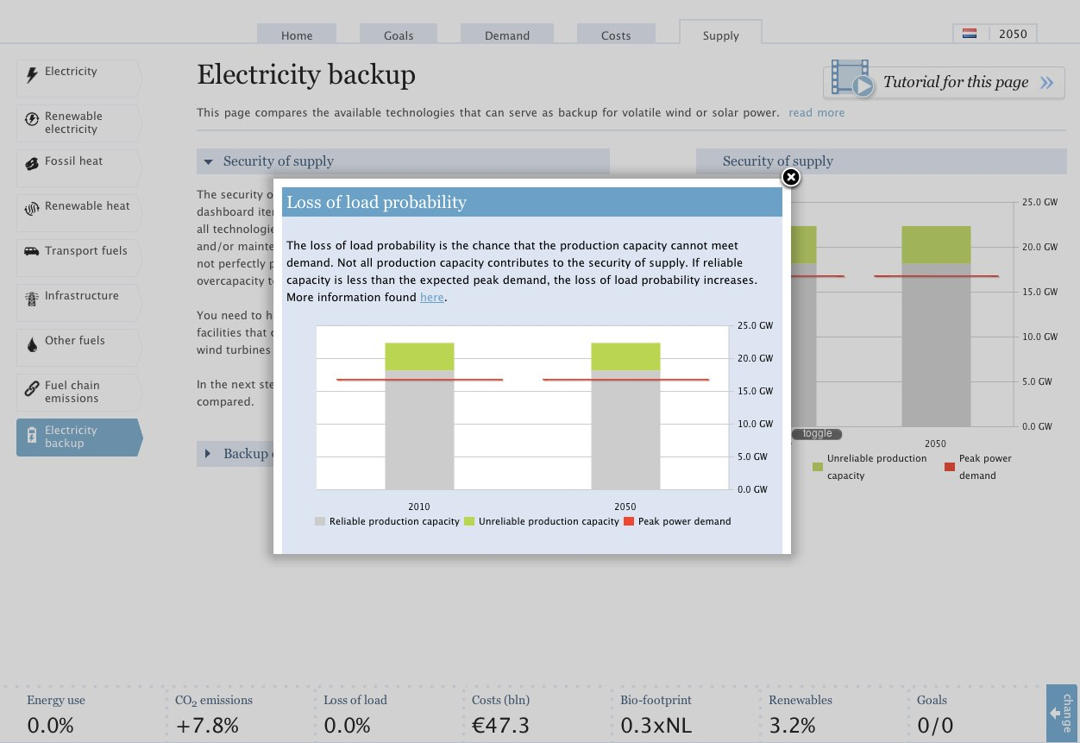
Figure 1: Information about the flexibility of electricity production is found both in the dashboard item as well as on its own page under the tab "Supply"

Backup for volatile electricity production

The backup for volatile electricity production module is found under the sidebar item “electricity backup” under the tab “supply” (found here). It consists of a scatter plot comparing different electricity backup options based on the additional costs and emissions that would be incurred on top of the costs and emissions of volatile electricity production. Figure 2 shows a screenshot of the scatter plot. For example, based on the figure it is seen that a Gas CCGT plant had additional costs of approximately 5 EUR/MWhe and emissions of 23 kgCO2/MWhe. Some important things to understand about the values expressed in the scatter plot:

- Everything is expressed per MWhe of the volatile electricity production. For example: an offshore wind turbine costs has levelised electricity costs of approximately 165 EUR/MWhe, on top of this an additional 5 EUR are required for the costs of the backup when using as Gas CCGT.
- The additional costs and emissions values are only those costs and emissions associated with the backup. For example: backup reserve capacity does more than only provide reserves, it also provides useful electricity. The costs associated with this useful electricity are disregarded. A Gas CCGT working at optimal efficiency produces electricity at costs of approximately 50 EUR/MWhe. When working to provide backup capacity, the Gas CCGT does not operate optimally and the electricity generation costs increase to 55 EUR/MWhe. Only the difference, 5 EUR/MWhe, is taken into account for the additional costs of backup capacity. This also applies for the CO₂ emissions. (note: this 5 EUR/MWhe difference is not the same as the 5 EUR/MWhe that is seen in the chart as more than only reserve costs are taken into account. The first value is in MWhe of the Gas CCGT power plant itself and the value in the chart is in MWhe of the volatile electricity production, that these two are the same is therefore only a coincidence.)

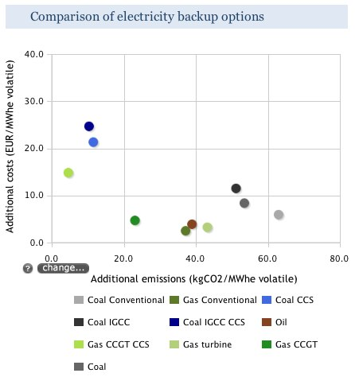
Figure 2: Screenshot of scatter plot showing comparison of electricity backup options

Calculation details

The calculation has two parts: Costs and emissions. The following things are taken into account:

- Investment costs of additional backup capacity. In other words, for every MW of volatile electricity production capacity a certain amount of MW of backup capacity is required. The investment costs for this backup are included.
- Extra operating costs of the backup due to needing to operate at a less than optimal efficiency to provide reserve capacity for shorter timer periods (<1 hr). As mentioned above, only the additional costs are taken into account by comparing the costs of electricity at optimal operation and at part load operation.
- Emissions of the additional capacity, which is required during longer periods of no wind or sun.
- Extra emissions of the backup due to needing to operate at a less than optimal efficiency to provide reserve capacity.

Costs calculation

The costs calculation is as follows:

$Costs=\frac{P_{ac}*IC+P_{sr}*OP*H*OC*\left(\frac{1}{η_{OP}}-\frac{1}{η_{FL}}\right)}{E_{vol}}$ (1)

With:

P_{ac} – Required additional backup capacity [MW], (equation given below)
IC – Cost of capital and depreciation costs of backup capacity [EUR/MW/yr]
P_{sr} – Required capacity for spinning reserves [MW], (equation given below)
OP – Operating point of reserve capacity [%]
H – Number of hours per year, 8760
OC – Operating costs of backup plant (i.e. fuel, CO2, and variable costs) [EUR/MWh]
η_{OP} – Efficiency at operating point [%]
η_{FL} – Efficiency at full load [%]
E_{vol} – Yearly volatile electricity production [MWh]

The required additional backup capacity is calculated as the difference between the capacity credit and capacity factor of the volatile electricity production:

$P_{ac}=\sum{P_{vol}*(c.f. -c.c.)}$ (2)

With:

P_{vol} – Installed volatile electricity production capacity [MW]
c.f. – Capacity factor of volatile electricity production [%]
c.c. – Capacity credit of volatile electricity production [%]

The required spinning reserve capacity is given by three standard deviations of the expected variability. The total variability is determined by taking the root of the sum of squares of the individual variabilities, including that of the demand as well as of the volatile electricity production. The demand variability is subtracted to determine only the portion related to the volatile electricity production.

$P_{sr}=3*\left(\sqrt{{\left(P_{d}σ_{d}\right)}^{2}+\sum{{\left(P_{vol}σ_{vol}\right)}^{2}}}-\sqrt{{\left(P_{d}σ_{d}\right)}^{2}}\right)$ (3)

With:

P_{d} – Peak electricity demand [MW]
σ_{d} – Variability of electricity demand [%]
σ_{d} – Variability of volatile electricity production capacity [%]

Emissions calculation

The emissions calculation is similar to the costs calculation:

$Emissions= \frac{P_{ac}*FLH*SE+P_{sr}*OP*H*SE*\left(\frac{1}{η_{OP}}-\frac{1}{η_{FL}}\right) }{E_{vol}}$ (4)

With:

FLH – The full load hours of the additional capacity [hr]
SE – The specific emissions of the backup capacity [kgCO2/MWh]

The full load hours of the backup capacity is calculated as the weighted average difference between the capacity factors and capacity credits:

$FLH=\frac{\sum{P_{vol}*\left(c.f. -c.c.\right)}}{P_{vol}}*H$ (5)

Example calculation

For an example of the calculation please see the Excel document available on the reference manager: “Flexibility of electricity backup – Example calculation.xlsx”

Information for ETM modelers

In the ETM the calculations are carried out through gqueries. The gqueries for this project can be found in the folder: etsource/gqueries/modules/security_of_supply/

The following queries are used:

- <converter>_in_overview_backup_capacity_options_costs – equation (1) above. 1 query per converter shown in the scatter plot
- <converter>_in_overview_backup_capacity_options_emissions – equation (4) above. 1 query per converter shown in the scatter plot
- additional_backup_capacity_required_in_mw – equation (2) above
- additional_spinning_reserve_required_in_mw – equation (3) above
- full_load_hours_of_backup_capacity – equation (5) above
- volatile_electricity_production – equation not listed here, but query calculates yearly electricity production by volatile technologies

Literature

- Meray, N., 2011. Wind and Gas: Back-up or Back-out, “That is the Question”.
- UK Energy Research Center (UKERC), 2006. The Costs and Impacts of Intermittency.
- Vourinen, A., 2009. Planning of Optimal Power Systems.
- Strbac, G., et al., 2006. Impact of wind generation on the operation and development of the UK electricity systems

