Merit order calculation in the Energy Transition Model

This document serves as documentation for the merit order calculation used in the Energy Transition Model created in cooperation with E.ON Benelux in January – March 2012. The document consists of four sections: an introduction followed by three sections used to explain each part of the merit order calculation.

Introduction
The ETM is a free to use energy scenario building tool available at www.energytransitionmodel.com. The ETM allows users to make assumptions about the future and subsequently calculates the implications of user choices. The model distinguishes itself from more complex models by providing real time results. To be able to provide these real time results the calculation possibilities of the model are often more straightforward.

Prior to this project one of the parameters that was considered static in the ETM was the full load hours of different power plants. This implied that regardless of the scenario, all power plants continue to operate in the future as they do today. This clearly is a gross simplification that needed improving.

By adding a merit order calculation to the ETM it has become possible to calculate the operating hours of power plants for future energy scenario. In this document it will be explained how the calculation works. The calculation consists of three steps:

- Merit order calculation – Calculate the operating (or ‘marginal’) costs of all power plants and sort them from lowest to highest
- Residual load duration curve calculation – Calculate the demand load profile that needs to be provided by power plants in the merit order
- Full load hours calculation – Based on the first two calculations, calculate how many hours each power plant operates

The main part of the calculation is the 3rd step, but the first two steps are not trivial. In the following sections each of the above steps will be explained to clarify how the full load hours are calculated.

Step 1. Merit order calculation
The first part of the calculation is to determine the merit order for the power plants that the user has decided to build. The merit order determines in which order the available power plants are used to meet the electricity demand (i.e. the cheapest electricity plants turn on first, and the more expensive ones turn on only if the demand for electricity is high enough). Figure 1 Shows a visualization of what a merit order looks like. It is seen that the power plants are sorted from smallest to largest depending on their variable costs.

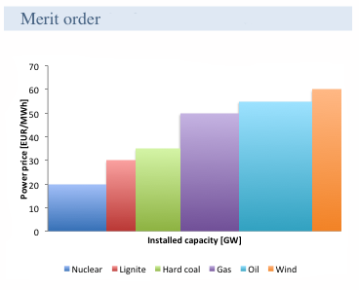

Figure 1: Illustrative merit order

The variable costs (aka marginal costs) are the costs of operating the power plant and include the costs of fuel, CO₂ emissions, and operation and maintenance costs. Investment costs are not included in determining the merit order. The ETM users can influence all the costs mentioned here, which changes the merit order.
The calculation of the variable costs is simple, for each power plant the fuel costs, CO₂ emissions costs, and O&M costs are expressed per MWh_{e} and summed up. For the 2010 start scenario, the variable costs of power plants in the Netherlands vary between about €6 and €84 for nuclear power (base load) up to gas turbines (peaking power), respectively. Note that these are the electricity generation costs and not the electricity price, i.e. no markup is included.
Knowing the variable costs of all power plants the merit order is created by simply sorting the power plants from lowest costs to highest. In addition to variable costs also the available capacity of each power plant is noted, this is represented by the width of each column in the merit order visualization in Figure 1.

Step 2. Residual load duration curve calculation
The next part is to calculate the residual load duration curve. First a short explanation will be given about what a load duration curve is. A load duration curve shows the fraction of time that the electricity demand is higher than a certain value; this is illustrated in Figure 2.

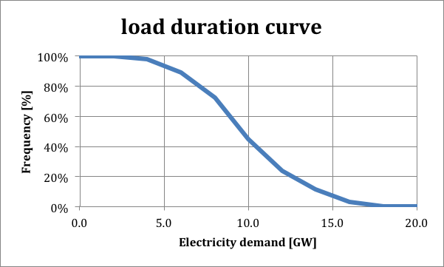

Figure 2: Illustrative load duration curve

In Figure 2 it is seen that 100% of the time the electricity demand is greater than 0GW, about 60% of the time the demand is greater than 10GW, and about 0% of the time it is greater than 20GW.

A load duration curve is made by taking the electricity profile over a period of time and calculating the percent of time that the load is higher than a certain value. This is done for the period of 1 year. To show how this works an example is given in Figure 3 using a single day. The load profile shows the electricity demand for every hour of a day. To calculate the load duration curve the values are sorted and it is determined how often the load is larger than a certain value.

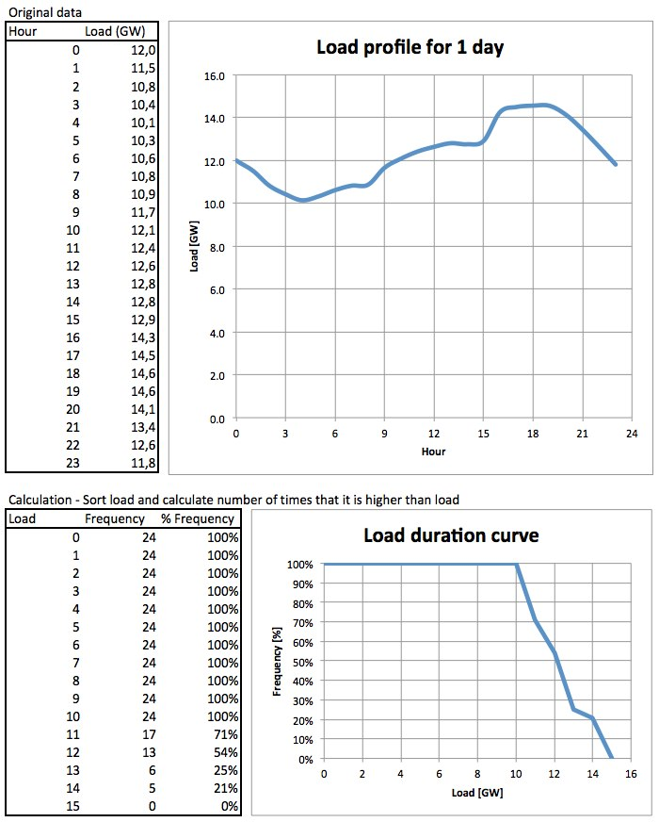
Figure 3: Illustrative load duration curve calculation.

A residual load duration curve (RLDC) is similar to a load duration curve only certain things have been subtracted, such as the power generation profiles of wind turbines, photovoltaic solar panels, and/or must run CHPs. Making a residual load duration makes it possible to visualize what demand needs to be supplied by centrally produced electricity. The creation of a RLDC is similar to the procedure shown above, but for clarity an example is given in Figure 4. In the figure the same load duration curve is shown as in the previous example with the addition of a few wind turbines. The wind power profile is subtracted from the load profile resulting in the residual load.

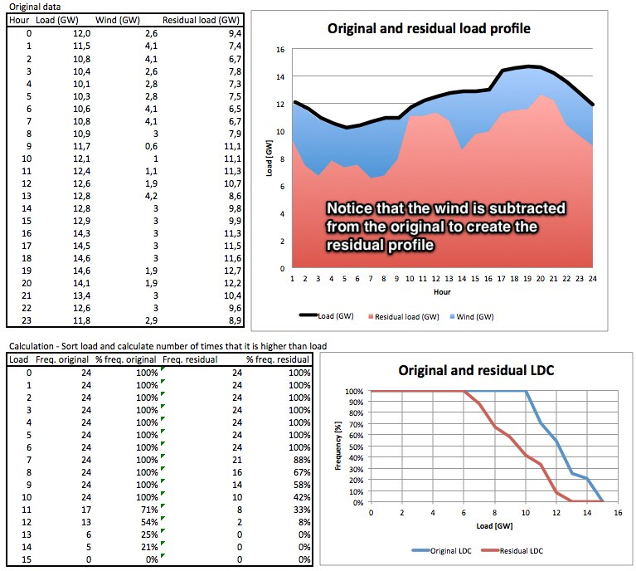
Figure 4: Illustrative residual load duration curve calculation

In the ETM the RLDC is created by using 8 profiles for 1 year of data:

- TenneT high voltage measured load data – scaled to the total electricity demand (since the TenneT data is only for the HV net the electricity demand is slightly less than the value found in CBS data for total final demand. Approximately 102TWh vs. 112TWh, so a small correction is applied) (Units - MW)
- Generation profiles for volatile energy technologies: (Units – MW/MW)
  - Offshore wind turbines – Average profile of 3 offshore sites – scaled to full load hours of research data
  - Coastal wind turbines – Average profile of 3 coastal sites – scaled to full load hours of research data
  - Inland wind turbines – Average profile of 3 inland sites – scaled to full load hours of research data
  - Solar PV panels – Average profile of 9 inland sites – scaled to full load hours of research data
- Generation profiles of must run capacity: (Units – MW/MW)
  - Industrial CHPs
  - Agriculture CHPs
  - Space heating and other CHPs

In the ETM each of the above profiles consists of 2190 data points, one data point every 4 hours. These profiles are based on the hourly profiles, consisting of 8760 points, however to reduce calculation times only every 4th data point was used. The effect of this simplification has been determined to be insignificant.

The generation profiles are expressed in MW/MW (i.e. normalized), expressing the profiles in terms of the installed capacity of the relevant technologies. Using the above profiles the RLDC is created by multiplying the installed capacities of each technology by the profile (based on the user input into the ETM) and subtracting these from the load profile. From the load profile the RLDC is created as has been explained in the previous figures.

In the next section it will be explained how the load duration curve is used in combination with the merit order to calculate the operating hours of the available power plants. To understand how this is done it is important to note that the area under the load profile and the load duration curve is equal to the electricity demand. This fact will be used to calculate the full load hours.

Step 3. Full load hours calculation
Using the merit order and the residual load duration curve, the full load hours of the electricity production technologies can be calculated. Because power plants are not always on and because they do not always produce electricity at full power, the term full load hours is used to define the equivalent number of hours that a power plant produces electricity at full power. The full load hours are calculated as:
$$FLH= \frac{electricity production [GWh]}{capacity \left[GW\right]}$$

For example, if a 1GW power plants produces 4000GWh of electricity, than it has 4000 full load hours. In reality however the power plant likely operates more hours than this, but not at full load.
From the above it can be understood that if the electricity production and the capacity of a power plant are known the full load hours can be calculated. These two parameters can be obtained from the load duration curve and the merit order, respectively. Figure 5 illustrates the theory of how this is done.

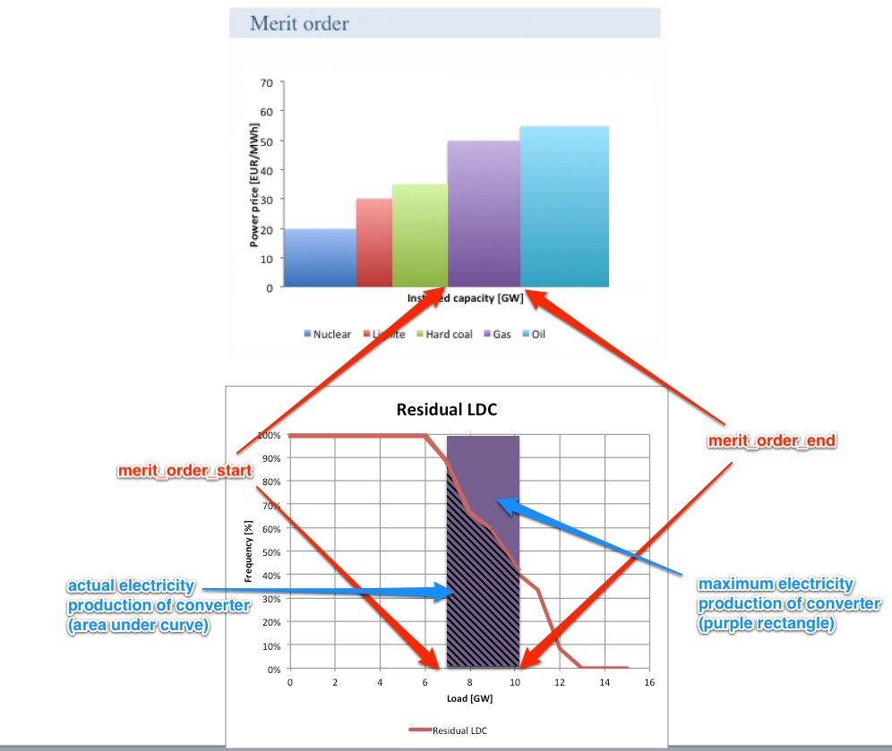
Figure 5: Theory of calculating full load hours using merit order and residual load duration curve

In the figure it is seen that the x-axes of the merit order and the load duration curve are aligned: The first power plants in the merit order provide the majority of the load and the more expensive power plants are used the least.
As was mentioned in the previous section the area under the load duration curve is equal to electricity demand/production. Therefore, by integrating the area under the residual load duration curve between the available capacity boundaries of each power plant the electricity production of each can be determined. This electricity production is divided by the capacity of each technology, resulting in the full load hours.

Full load hours are the equivalent number of hours that a power plant operates at full load based on its yearly production and capacity

